Course Name: | EEEE | Semester: | I
Date of Performance: | 25/11/2022 | Batch No: | C3-3
Faculty Name: | Annu Abraham | Roll No: | 16010122221
Faculty Sign & Date: |  | Grade/Marks:

Experiment No: 6
Title: Zener diode voltage regulator

Aim and Objective of the Experiment:
- To understand the working of Zener diode as voltage regulator
- To calculate line and load regulation of Zener diode based shunt regulator

Requirements:
Zener diode, resistor, potentiometer, voltmeter, ammeter, DC source and bread board.
Link for virtual lab:
https://portal.coepvlab.ac.in/vlab/auth/home?dept=2&lab=10

Theory:
A zener diode functions as an ordinary diode when it is forward biased. It is a specially
designed device to operate in the reverse bias. When it is in the reverse breakdown region, the voltage (Vz) across Zener diode remains almost constant irrespective of the current (Iz) flowing through it. A series resistor A series resistor Rs is used to limit the zener current below its maximum current rating. The current through Rs is given by the expression is IS=IZ+IL , where IL is the current through the load resistor . The value of Rs must be properly selected to ensure break down of the Zener diode and also to keep Iz in limited in specified current limit.
Rsmin= (Vin-Vz)/Izmax (1)
Rsmax= (Vin-Vz)/(Izmin + IL) (2)
Design steps:
1. If for regulator
Desired output parameters Vo=5.6 V, ILmax= 5mA
Input voltage in the range VIN = 8 V- 14 V
2. Choose Zener diode (5.6 V, 45 mA)
3. Choose potentiometer of value 4.7 kΩ so that IL can be varied from 5.6/4.7 kΩ ≈ 1.2 mA.
4. IZmax = 45 mA so IZmin = 10% of IZmax = 4.5 mA
5. RSmax = (VINmin - VZ) /(IZmin +ILmax) =(8-5.6) V/(4.5+ 5.0) mA ≈ 253 Ω
RSmin = (VINmax - VZ) / IZmax = (14-5.6)V/(45 mA) ≈ 186 Ω
Choose RSmin < Rs <RSmax so Rs = 220 Ω and Power rating (Imax)2 x RS
Imax = (VIN - VZ )/ Rs = (14-5.6) / 220 = 38 mA
Power rating = (38 mA)2 x220 = 0.32 watt ≈ 0.5 watts.

Circuit Diagram/ Block Diagram:
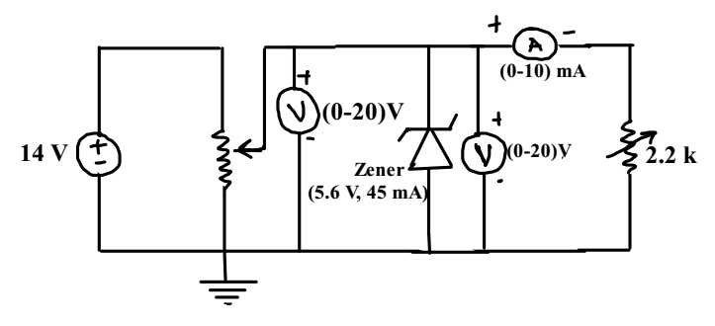

Stepwise-Procedure:
- Design circuit and connect it as shown in the circuit diagram using Proteus simulator.
- Keep VIN more than 8V and adjust Potentiometer RL such that IL= 5 mA. Vary VIN and Note VO for finding line regulation.
- Keep VIN = 10 V and vary Potentiometer RL such that IL changed from 0 to 5 mA and not VO for finding load regulation.
- Plot the graph Vo Vs VIN for line regulation and Vo Vs IL for load regulation.

V-Lab/Proteus Screen shots
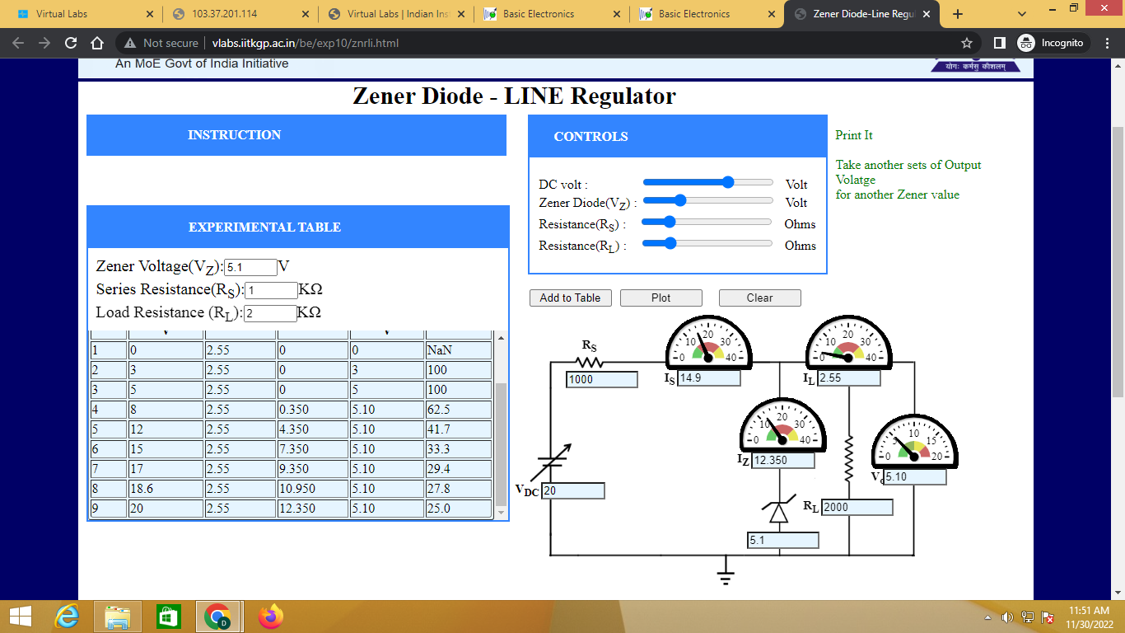
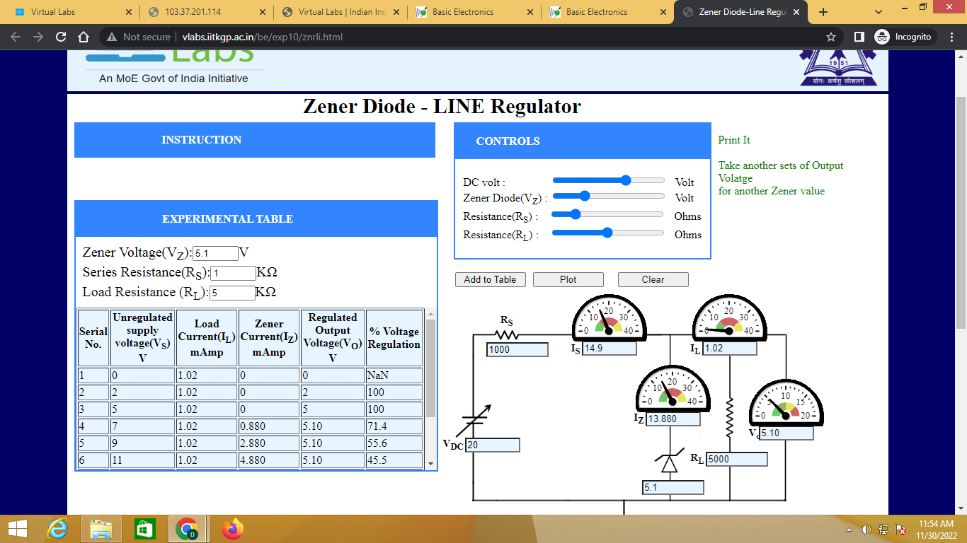

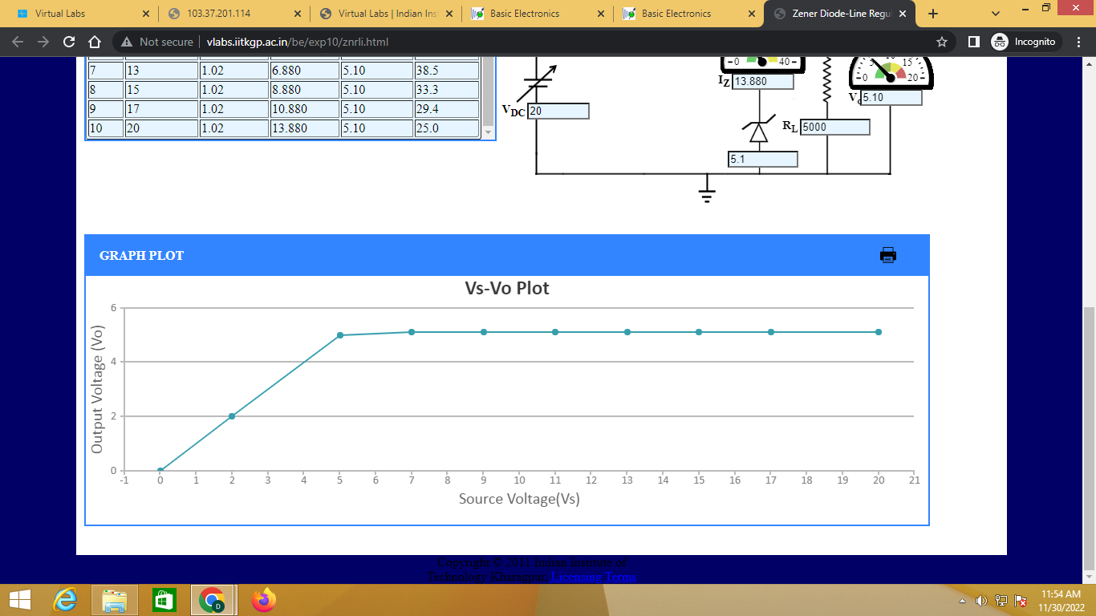

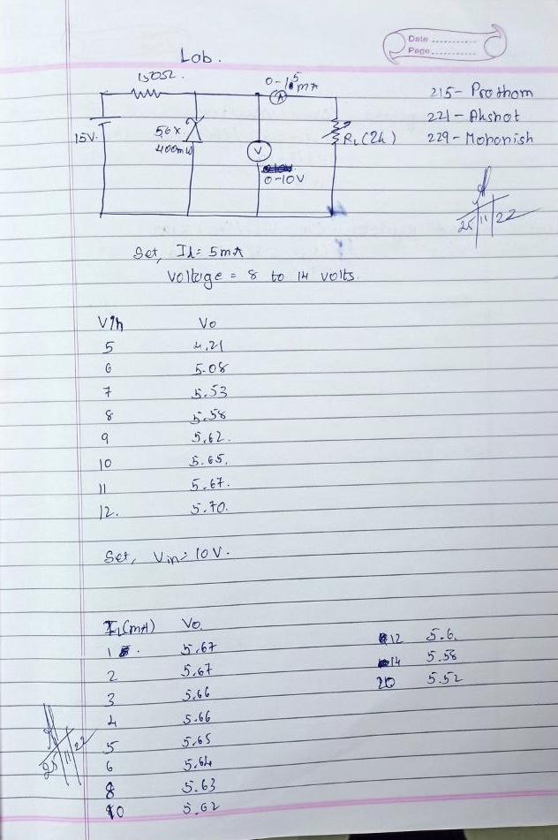

Observation Table:
Line Regulation: Set IL= 5 mA Load Regulations: Set VIN= 10 V
VIN (V) | Vo (V) |  | IL (mA) | Vo (V)
5 | 4.21 |  | 0 | -----
6 | 5.08 |  | 2 | 5.67
7 | 5.53 |  | 4 | 5.66
8 | 5.58 |  | 6 | 5.64
9 | 5.62 |  | 8 | 5.63
10 | 5.65 |  | 10 | 5.62
11 | 5.67 |  | 12 | 5.59
12 | 5.70 |  | 14 | 5.58
13 | 5.71 |  | 16 | 5.57
14 | 5.74 |  | 18 | 5.56
15 | 5.77 |  | 20 | 5.55

Post Lab Subjective/Objective type Questions:
1. Draw and explain I-V characteristics of Zener diode.
Ans a. Zener diode is p–n junction diode manufactured to operate in breakdown region.
b. Its forward bias characteristic is same as that of ordinary junction diode. This means current does not flow until bias is less than barrier potential. Current increases rapidly beyond it with increase in forward voltage.
c. In reverse bias, initially a small reverse saturated current flows and at particular value of reverse voltage, increases suddenly. This voltage is zener breakdown voltage (Vz)Read more on Sarthaks.com - https://www.sarthaks.com/1282409/explain-i-v-characteristics-of-zener-diode-with-suitable-graph
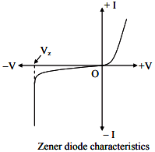
2. What is difference between PN junction diode and Zener diode?
Ans The major difference between a PN junction diode and a Zener diode is that a PN junction diode allows the electric current to pass in only one direction (or forward direction), while a Zener diode allows the electric current to flow in both forward and reverse directions

Conclusion:
We studied the property of zener diode.

Signature of faculty in-charge with Date:

